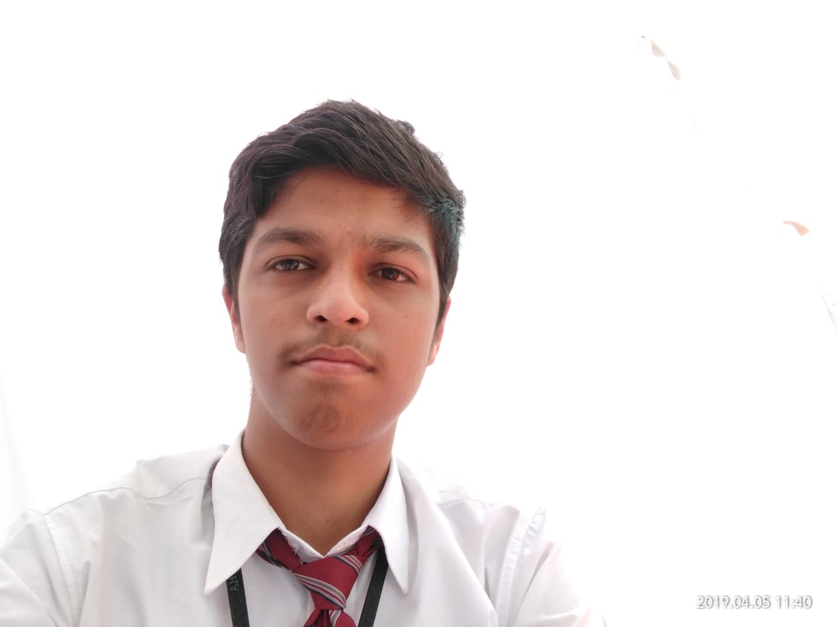

**EDUCATION**

Bachelors in Information Technology Engineering | Chandigarh University, Gharuan

*Session: 2018-2022 | Score: 7.0 CGPA*

Intermediate (CBSE) |ABC Public School, Gorakhpur

*Session: 2017-2018 | Percentage: 68.8%*

Matriculation (CBSE) | ABC Public School, Gorakhpurs

*Session: 2015-2016 | Percentage: 79.8%*

**TRAINING & PROJECTS**

**Suven Consultant PVT LTD | INTERN**

October 2021-Present

* 365- Entertainment similar to Hotstar.com
* Blogging similar to Medium.com
* CSS3 Animation
* Voter registration Replica of voter service portal form

**The Spark Foundation | Intern**

October 2021-Present

* Basic Banking Site

**University Project | Student**

October 2021-Present

* Personal Aid

**ACADEMIC ACHIEVEMENTS**

* Filed 6 patent in 1 year and 4+ in process.
* 30/30in both project 1st year.

**CERTIFICATIONS & AWARDS**

* 30 days of google cloud program
* Digital Marketing at Tutedude.
* IIRS Outreach Program “Space Technology and its Application”- ISRO

**EXTRA CURRICULAR & CO-CURRICULAR ACHIEVEMENTS**

* Gold badge in C++, java, and python Hackerrank.
* 3317 rank in Project Euler Hackerrank.
* 2 Repository in Artic Code Vault.

**Priyanshu Singh**

Address: Shivpur Gorakhpur UP- 273008

E-mail: *[18bet1057.it@gm](mailto:1234abcde@gmail.com)ail.com*

Phone: +91 6388016659

LinkedIn: https://www.linkedin.com/in/priyanshu-singh-a035a218a/

**PROFESSIONAL SUMMARY**

[I'm all time motivated and hardworking pursuing my graduation with bachelors of engineering in Information Technology, I know various technologies required for modern challenges. I'm good at time management and always take my work as a priority.](https://priyanshu1stportfolio.netlify.app/" \t "https://www.linkedin.com/in/priyanshu-singh-a035a218a/detail/featured-list/urn:li:fsd_profile:ACoAACyU2SMBqwn2gQPH1zeZQPe2bUt3L8J6thw/_blank)

**TECHNICAL COMPETENCIES**

C++ | JAVA | PYTHON | CLOUD |

 

**INTERPERSONAL SKILLS**

Team Leadership **|** Teamwork **|** Motivation

**INTERESTS & HOBBIES**

Writing **|** Gaming **|** Music **|** Travelling **|** Reading

**LANGUAGES KNOWN**

English **|** Hindi **|** Punjabi **|** French

**PERSONAL DETAILS**

Mother’s Name: Anju Singh

Father’ Name: Praveen Singh

D.O.B.: 16/08/2000

Languages Known: English/Hindi